***University Registration System Schema***

**Problem Statement:**

Design a robust database system that supports the storage and retrieval of university-related data, ensuring accurate student records, seamless course registration, and optimal administrative processes.

**Key Requirements:**

1. Student Information: Capture and store essential student details such as student ID, name, contact information, and academic program.

2. Course Information: Design tables to store course details, including course codes, names, credit hours, and instructors.

3. Enrolment Records: Create tables to manage enrolment records, linking students to specific courses, recording enrolment status, and grades

4. Faculty Information: Capture and manage information about faculty members, including names, contact details, and academic departments.

5. Academic Programs: Design tables to store information about academic programs, including program codes, names, and requirements.

6. Class Schedules: Implement tables to handle class schedules, connecting courses with specific time slots, days, and locations.

7. Prerequisites : Create tables to manage prerequisites for courses to ensure proper academic progression.

**Deliverables:**

1. ER diagram

2. Database design

3. Tables with at least 10 records.

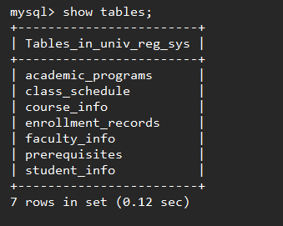

Table 1 : academic_programs:

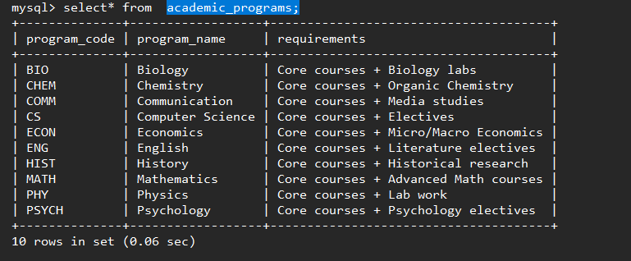

Table 2: class_schedule

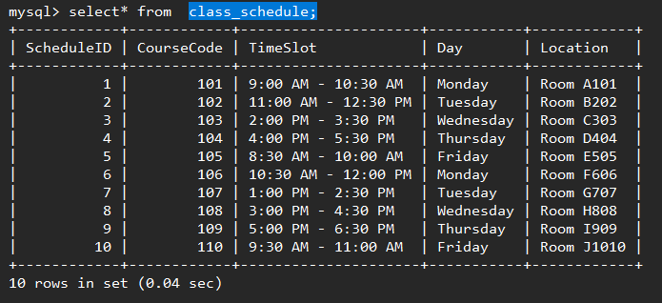

Table 3: course_info

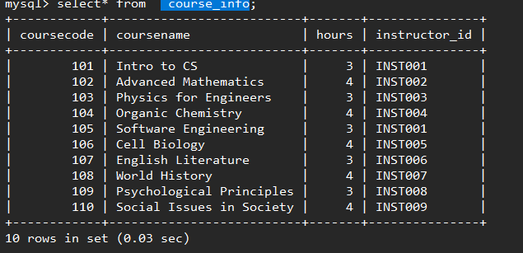

Table 4: faculty_info

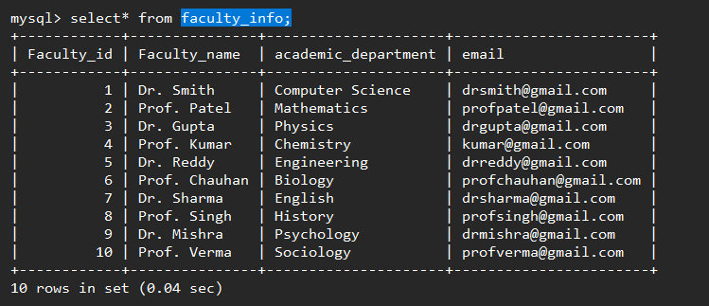

Table 5: student_info

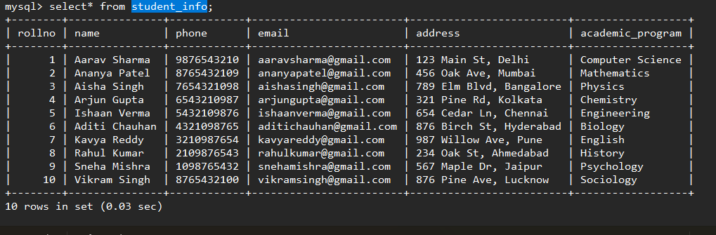

Table 6: enrollment_records

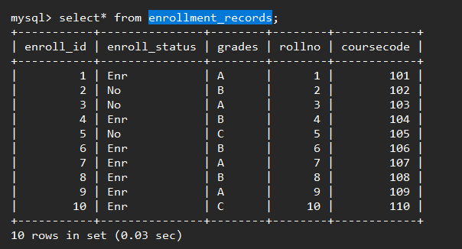

Table 7: prerequisites

